Value Of Bread And Labor More Important Than Gold
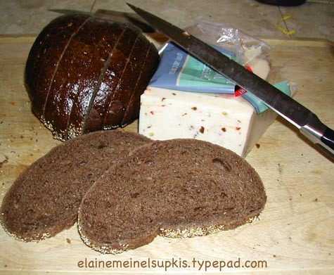
February 1, 2008
Elaine Meinel Supkis
Time to talk about the relative value of gold, suits, silver and bread. People in the gold bug community have been trying to convince me that gold never really fluctuates vis a vis things we buy. I have to dash that mad idea on the rocks of reality! ALL things fluctuate according to availability of labor, changes in trade, wars, pestilence and famine. The Four Horsemen rule the relative value of all things! The one thing we must pay attention to is not the value of gold but the value of a loaf of bread, the staff of life itself. History goes through really violent contortions because of variations in the value of bread vis a vis LABOR, not gold.
Antal E. Fekete
China is the only country in the world that has consistently run trade surpluses since 1950. As far as it is known, silver never figured in China's exports (except re-exporting foreign-owned refined silver.) Why should the Chinese export silver, when they could export almost anything else? Silver to the Chinese mind is money. You don't export money unless you are forced to cover your trade deficit, of which China has none. China has always paid for its imports with exports, a smart thing to do, too.
The Chinese are alive to the fact that escaped the silver bugs in the West, that you can derive a silver income from your pile of silver by covered short selling, even while retaining physical control of your silver hoard. THIS IS AN UNPRECEDENTED BONANZA IN THE HISTORY OF MONEY. It has never before happened that you earn interest while retaining physical control of your money. Typically you have to release control of money in order to earn interest income, that is, you have to assume risk. Lending money necessarily involves risks: the borrower may default. But if you don't give up physical control, then you will escape the monetary debacle unscathed. Because of the imbecility of the managers of the paper dollar standard there exist durable risk-free profit opportunities in holding monetary metals in the balance sheet. The trick is: covered selling. That's possible because the price of monetary metals has been allowed to fluctuate. The price fluctuation of a monetary metal, like the flow-and-ebb of the oceans, represents energy. Energy that can be harnessed. Energy that can be harnessed only by those who understand monetary economics.
Lately, I have decided to pick a series of fights with people peddling the idea that gold or silver are nostrums for financial disasters. Even though history clearly shows us that no metal has ever created a stable environment, this belief is sustained by false analogies designed to fool people. Like the crazy story that gold always buys the same stuff all the time. If this were true, we would be using it as a currency. But this is NOT true at all and I have seen no proof of this. Being clever, the people peddling this false ideology [it is like all propaganda, based on assumptions] like to use the notion, gold is worth the same as a suit of clothes over the centuries.
This is ridiculous. The components of clothing change tremendously. The amount of frills, buttons, cloth used, type of material, length, etc, changes wildly from generation to generation. And what is the price? A suit made in different venues varies within the same time frame quite wildly. Are we talking 'top of the line' suits? Then how can this compare to a 'top of the line' suit in 1760 for example? A top of the line suit was totally different from the standard middle class suit! Not to mention, the ermine cloaks! And the amount of gold and pearls varies tremendously depending on which top person we are talking about. The Kings of Europe and their Queens wore tons of gold when the New World was looted, for example!
A suit in 1780 France was totally different from the 1790 suits. A lot of suits lost their heads on the guillotine in between!
The thing to track is the cost of bread. Gold and bread have an ancient rhythm. If bread is scarce, the value of gold plummets in relation to bread. Indeed, the connection of gold to dresses is similar and connected to bread: a suit in France in 1780 was worth a lot of gold. In 1790, even the rich were getting rid of these expensive suits and changing to sans culottes with the peasant pants look and wigs were right out. But what triggered this? The price of gold? Or the PRICE OF BREAD?
Of course, when bread beat gold in the markets, bread became PRECIOUS. Marie Antoinette, when she still had her fancy gowns and bewigged head, reportedly said, 'Let them eat cake.' Of course, the food riots led to revolution. The history of mankind is one of the rich clinging to their gold while people riot over bread! The people also want free loans, of course. Which is the modern form of bread.
Denying people the ability to get loans leads to riots. When Volker raised interest rates so people wanted to save rather than spend, farmers stormed Washington, DC, demanding loans at a lower rate. To run a modern economic system you need loans! The problem we see today is classic: the price of gold and food are rising fast, together. And this is causing great financial suffering at the bottom where the food matters and gold is immaterial.
On top of all this, we have a collapse of the community. Gold hoarding doesn't save anyone, it takes money OUT of the economic cycle and buries it in some cave, treasure chest or grave. Fort Knox is a dead place. It costs the taxpayer a lot of money to run. It had to be built. It had to be very strong. It needs guards who get paid to stand around, doing nothing. It produces nothing at all. It is there as a warning more than as a gainful enterprise. The more people put their wealth into inert gold, the more we go into a depression. This is why ALL governments stop gold hoarding during depressions and force money back into the stream again.
In old Europe, they hoarded, too, when things went bad. This could lead to disaster. What they did about this was go to war. If the King of Spain hoarded gold, the English would raid Spanish ports for gold. Just for example. Holders of gold who can't be attacked simply sit in a depression. The US did this until the Japanese attacked. Gold hoarding only attracts pirates and war.
This article above irritates me. The US uses its gold hoard to sell shares, to use as a thing to put into hock only unlike with the pawn shops, the US gets to hold this gold which is used in hock. We imagine this will allow us to have our cake and not have our heads chopped off, too. The Chinese hold their hoards, too, for the same reason and the same way. Most gold speculators never see a glint of gold. They let others hold the gold. If you buy physical gold, it costs more than the world price because of shipping and handling. Holding gold is expensive. If you can't lend something based on it, you lose potential value. So most gold traders keep the gold in someone else's lap. This means they are really trading or talking about paper, not gold.
Indeed, gold is prone to collapse. Everyone trusts the gold is in an account, it is there, where we can touch it. But when the safe is opened, it sometimes is bare or the gold isn't pure at all, as the Brits discovered recently.
Now on to silver: The value of silver had a wild peak and then a total, multi-year, nay, multi-decade collapse. Unlike gold, it hasn't even begun to reach its old peak during the bubble. Chart courtesy of Amark.com: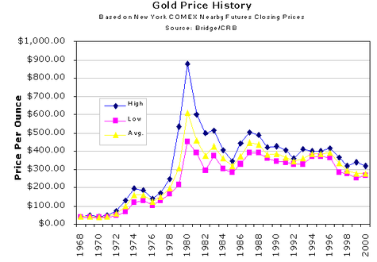
Here we can see that gold's peak climb began when silver began and it collapsed at the same time. This shows us that it is money seeking balloons, not money being invested, at work. The gold peak and collapse is identical to the earlier silver peak/collapse. This can't be explained away as 'inflation.' Inflation began long before the peak and it ran along afterwards, just not quite so high. The key here is the level of interest rates allowed by the Federal Reserve. Like today, the foolish idea that we can have low rates below inflation while not having every possible bubble continues!
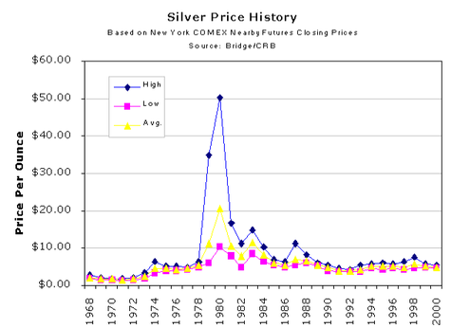
We can see from this other precious metal, the same peak/collapse. It, too, is rising. A tad later than gold. Gold has been the latest hula-hoop mania here and silver has barely begun to climb. I expect silver to climb if the Federal Reserve continues to keep rates well below inflation. Remember: it isn't the inflation, it is the INTEREST RATES that matter.
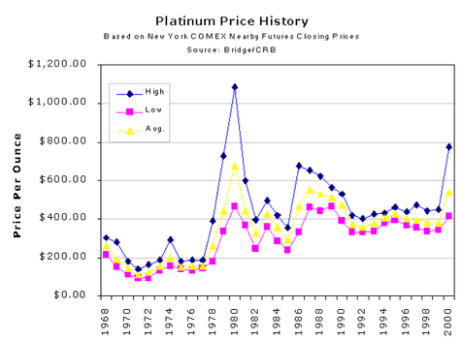
Personally, jumping onto the wagon that is further along the boom/bust road is dangerous. This is probably why more people are moving into silver. It has barely begun to balloon. And these balloons are very dangerous, every bit as dangerous as real estate speculation or other games. Buyers, beware! But so long as Bernake thinks the Fed is to feed us free money, go for it. Just don't pretend gold brings fiscal stability.
Back to bread: this is the keystone item to watch if one wishes to predict the future and understand politics and human history. The value of gold and silver vis a vis bread has a long, ugly, nasty history complete with screaming hoards with torches and pitchforks and guns going off in revolutions and wars. And this is what interests me: the human dimension.
From the Victorian Web:
The agricultural laborer in the mid fifteenth century could buy 23 pounds of bread with a day's wages. In fact, he was frequently fed for free by the proprietor, and the meals were not charged against his wages, so his purchasing power was even higher. The more skilled artisan could buy 34 pounds of bread, which puts him at a standard of living which is 9 times higher than the Speenhamland subsistence allowance. It is obvious that these wages provided sufficient income for a wife and children.
By any measure the eighteenth-century handloom weaver working his loom at home was a skilled artisan. In 1798 his purchasing power was 28 pounds of bread, again easily enough to support a family, although somewhat less than the carpenter earned in 1450. With the introduction of the power loom under the factory system, his wages fell to a mere one-sixth of their former purchasing power by 1831. To put a more human face on this statistic, imagine a 25-year-old hand loom weaver in 1798 with a family, good home, and income; by the time he was 58 years old, his income was reduced to the subsistence level, and getting worse with each passing year.
*snip*
By 1865 the purchasing power of even a skilled town laborer working his trade had fallen to a level of less than twice that of the Speenhamland allowance, putting the great bulk of independent town laborers barely above subsistence. Booth estimated that around the turn of the century 31 percent of the population of London was living in poverty. This estimate was confirmed by the studies of Rowntree in the City of York, where he found the proportion of the inhabitants in poverty (that is, below subsistence) was 28 percent.
Time for more charts! I love charts. Anyone can say anything but looking at some data helps a lot. Note how the value of labor fluctuated wildly like it does today!
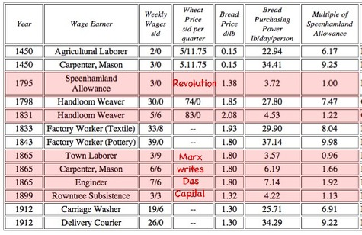
I took the liberty to note some basic facts. Marx gave birth to Communism during the long collapse of working wages in England. The pre-New World European worker got much better pay than the post-New World workers. If this chart went back to the pre-Black Plague, it is similar. Before the grim reaper eliminated many peasants, they were near starvation. Afterwards, labor was dear and wages climbed rapidly to the tremendous annoyance of the ruling class land owners like my own family. We couldn't abuse the laborers who demanded more beer and some pennies for doing the ancient duties of harvesting our crops before harvesting their own. Namely, they were our slaves up to a point. And if we were nasty, they would take their cow and their scythes and move do a vacant farm on some other, more generous lord's land.
Indeed, the very name, 'lord' comes from Old English for a loaf of bread. The lord was the master of the bakery's output. The affairs of state and the value of a loaf of bread and what ratio this was in relation to the wages of the workers was and still is, literally life and death for rulers! So we have many records of this.
Gold wasn't used as a basis for this agricultural mix. It has two purposes only: war and international trade. When gold poured into Europe after 1500, the value of wages dropped not just because of inflation but because a new labor force appeared suddenly by the millions: African slaves. They were not brought into Europe, they were like Chinese workers are today to us in the US: work went to THEM and THEY were kidnapped to plantations in the New World to produce agricultural and mineral wealth which poured directly into the purses of the rich and powerful and of course, pirates like my ancestor, pirate Pettit.
The Industrial revolution also depressed wages. It wasn't until after WWI that Europe's poor peasants who poured out of that deadly trap and flooded into free lands, that European peasants and workers both began to see improvements in their sorry lots. The only role gold played in all this was to be the basis for hiring foreign mercenaries to keep down the people at home. Aka, the Hessians in the New World, for example.
Today, we are seeing a full-scale banking collapse coupled with a bread crisis as the price of bread is spiking higher and faster, globally, than gold, silver or oil. This is a crisis for the Chinese, the Mexicans, all of Africa and even in the US, it is beginning to nibble at even our own incomes. But the real fall in income has nothing to do with gold and EVERYTHING to do with foreign labor being used to flood markets so the rulers can pocket this gold and anything else they can lay their larcenous hands on.
Reserves of depository institutions
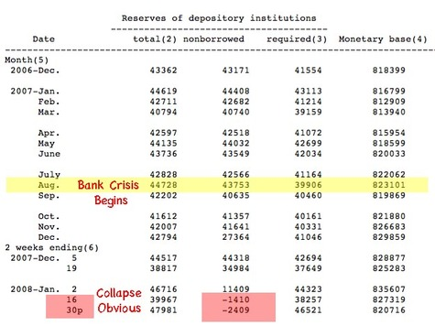
We are in the negative. I have never seen this in my life. I know it happens in history. Rich people better watch out. They should not say, 'Let them eat...' ANYTHING. The easy loans can only happen when banks have savings and since their asset base in the form of previous loans are now being dragged heavily into negative territory and much of this is since Xmas, they CANNOT give loans of ANY SORT at any price. They are in a negative flow trap. The ONLY out is to RAISE INTEREST RATES. Volker is chomping at the bit on the sidelines with fury. He knows, like me, this is the only way out.
Since the US has chosen to run all things in the red, it doesn't surprise me much to see ALL things running in the red. Nor should it shock the Fed. Lowering interest rates so money flows in the red all the time will make this red ink sea worse, not better.
From Calculated Risk comes this pdf file of a letter from Countrywide which shows how much things are shutting down due to a collapsing asset base:
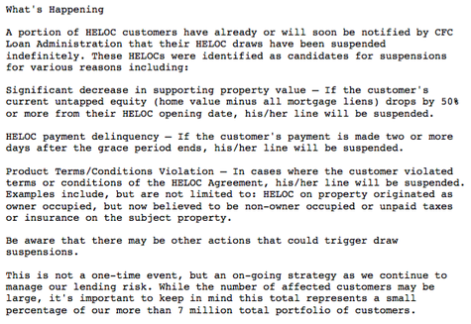
The HELOCs are open accounts one can tap into for funds. When the whole banking system went into the red, even after the Bank of America infusions, Countrywide has no more capacity to make loans at any interest rates at all. This is what the 'loss of liqudity' is all about. The relatively tiny sums going into default at the bottom of the economic ladder are also depressing the assessed value of ALL OTHER assets. And banks don't just own properties, they own loans. If these go indefault, the collective value of other loans and the properties they are based on, fall. This is called 'the equity trap' and I call it 'The Horns of Dilemma.'
BNP Paribas Weighs SocGen Offer After Trading Loss
BNP Paribas SA, France's biggest bank, is considering a bid for Societe Generale SA a week after its smaller competitor said a trader's errant bets led to a record 4.9 billion-euro ($7.2 billion) loss.
``Like everyone in Europe we are thinking about what this situation means for us,'' said Jonathan Mullen, a spokesman for Paris-based BNP Paribas, which failed in an attempt to buy Societe Generale in 1999. Earlier, a spokesman who declined to be identified said the bank is studying a possible offer.
Even as the banking crisis is unfolding and destroying the financial base of the West, the surviving banks look to consolidate power. In all crashes, we get increasing monopolies. After the Panic of 1873 and 1893, the biggest players grew very big and formed monopolies and interlocking cartels. This became the 'Gilded Age' thanks to them. Teddy Roosevelt gave them a horrid scare when he ran for office against them and began to pass laws hindering this consolidation powers.
We are in the midst of a tremendous buy-up/hostile take over process today! Microsoft, a huge combine, is now trying to take over a weakened Yahoo. Steel makers, mining operations, shipping companies, manufacturers are all consolidating power and a new combine of interlocking cartels are rising. The Chinese are very aware of this, they are one of the biggest forces at work, doing this. They have a monopoly in power within China and hope to gain it outside, too.
The US won't benefit from all this. Since the entire point is to fleece the consumers. That is, more or less, us.
US recession will dwarf dotcom crash
By Edmund Conway, Economics Editor in Davos
The views of Stephen Roach, one of the world's leading economists, now heading the Asian wing of Morgan Stanley, would have seemed outrageous at last year's World Economic Forum.
It is a sign of the times that they are now close to the consensus. This year's event has been dominated by discussions of the stock market slump on both sides of the Atlantic, the Federal Reserve's emergency interest rate cut and the SocGen fraud disaster.
But underlying everything has been the silent truth that the US is facing a very possible recession, and is fast having to adapt to a far less enjoyable economic climate.
"We have, as relatively sophisticated, well-developed economies, gotten hooked on credit as never before," said Roach, speaking about the UK and US. "If we had been running our economies the old-fashioned way, for example, where saving and consumption were funded by income, maybe we wouldn't be in this mess we are in now.
Throughout history, the peasant has avoided debts and tries to translate wealth into expanding their farms. This is why the freed peasants of the Ukraine irritated Stalin so much. They wanted more land and more control over their production. Stalin, a statist monopolist, wanted to consolidate his power. I am a true conservative: I believe in the wisdom of the past. The painstaking building of laws, customs and practices has real worth. Instead of dealing with problems directly, our upper classes decided to circumvent them by altering everything. They warped, shredded and ignored nearly everything useful that grew up so painfully over the last 500 years.
This is now collapsing. And only a return to the old ways can save us. Gold and silver can be part of this, as I often point out. But NOT if it is used by speculators. The easy tool to keep control of both metals as well as the value of the papers issued by governments is to have realistic interest rates. This simple cure is the one everyone, gold buyers, governments, lenders, businesses and consumers ALL want to avoid like the plague. The only people happy with this are people who aren't deep in debt, gamblers or warmongers. Namely, that unicorn in our economy: the savers. There are so few now, there is little constituency for raising rates at all.
"I think everyone is being too gloomy about 2008," he said. "This year could be a lot better than many expect for both the US and the UK. I suspect 2009 is the year to be more worried about."
Much depends on the reaction of policymakers, who are already considering imposing new regulations on banks, whose use of sophisticated financial products contributed to the crisis.
Roach added: "There will be sand put in the gears of financial market innovation. Some of it will be justified but it will go too far. It's a significant risk."
US investment banks, meanwhile, are already having to turn to sovereign wealth funds (SWFs) from Asia and the Middle East to provide an unprecedented injection of funds to keep them afloat. Roach sees it as part of a wider question. "We are dealing with an incipient recession. Who's going to fund us? We don't have the wherewithal to fund it."
They are NOT imposing 'new' regulations, they are restarting old ones. The rich speculators, bankers and financiers all pour billions of dollars, world wide, into the purses of the politicians who are supposed to control them. They also run media organizations that lose money on the surface but work as propaganda outlets to mislead, misinform and outright lie to the populace. This is why I will never be published by these billionaire's media. They pay this money to get FREE money with no basis in savings. This money then is used to not only create massive bubbles but to feed the real monster lurking behind this banking collapse: derivatives. The refusal to even talk of this mother of all balloons is significant.
Gold can't fix this monster. All the gold, all the wealth of the world is rapidly being devoured by this creature. ANY downturn in the world's economy will release this $500 trillion beast. And the banking system will cease to exist and the only solution will be total chaos. And gold's value will be less than bread in this matter. That, and the tools one uses to gain power and as Mao noted sardonically, 'Power grows out of the barrel of a gun.' I said earlier, if I were to be given the choice between control of all the world's steel or all the world's gold, I would follow my ancestral name and choose 'steel'. When William the Bastard gave us that name, it was because of our shield and sword, not because we had a fat purse.
U.S. loses its status as economic world power
What makes the American case so acute, in foreign eyes, is that it comes at a time when the United States is massively in debt to China and oil-rich countries like Russia and the nations of the Arab gulf. As America cuts interest rates to keep banks solvent, the dollar becomes less attractive to those countries who are keeping America afloat. Yet we need their capital to keep our ailing banks afloat.
What was also stunning at this year's Davoswas the growing self-confidence of Asian nations (except for Japan, which stayed much on the sidelines). China now sends large numbers of English-speaking entrepreneurs to Davos who are investing globally and mix on equal footing with top Western executives. All the panels on Asia were oversubscribed.
"It's remarkable how few have noticed we are entering an entirely new era of history - the rise of Asia," says Kishore Mahbubani, dean of Singapore's Lee Kuan Yew School of Public Policy. "By 2050," he adds, "the world's four largest economies will be China, the United States, India and Japan" - in that order.
Um, the Japanese are keeping a low profile because they are now madly triangulating with China and don't want the Americans and Europeans to notice this. Much of my news about Japan comes as a shock to readers who haven't been with me since 2005 when I began this news service here. 99% of what goes on in Japan is not reported in the West. And the Japanese prefer this. They want us to think about them as a bunch of anime otaku.
As for 'few noticed' this: HAHAHA. Mr. Mahbubani knows perfectly well why this is so. Japan needed the cover of their fake depression that features world-record-breaking trade surpluses to get the US off its back. In the 1980's, there was real fear about Japan's powers. Now, it is on China. And the US is very aware of rising Chinese power. But it isn't just China: any nation with a reasonable banking system and no EXTERIOR debts is going to be the future rulers of the earth. And they do NOT want us to know this. For we still have time to change direction.
All we have to do is raise interest rates to be above inflation.

